Mininet Installation
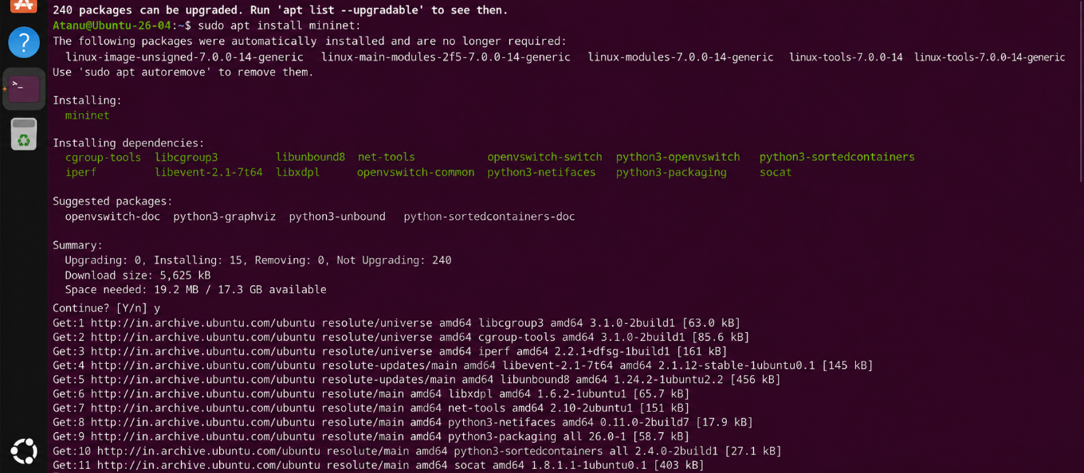

Topology
1.Star Topology
- Star with 2 hosts
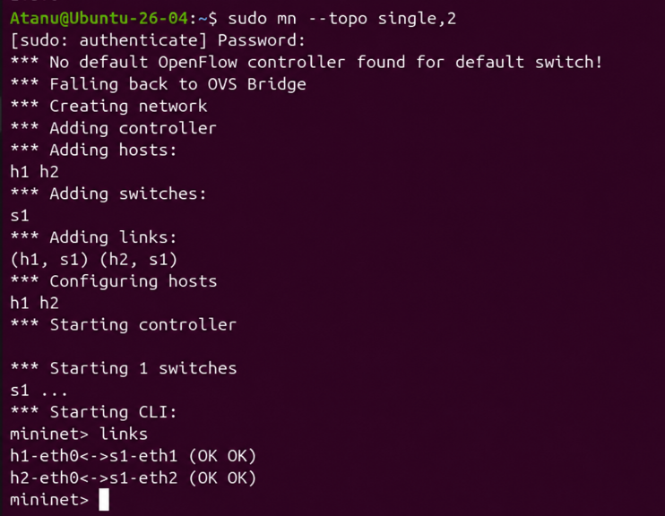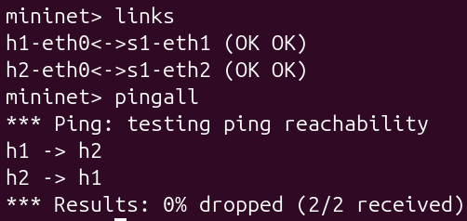
Pingall Links
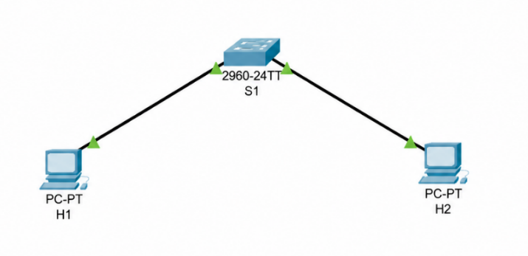
Diagram: Star With 2 host
- Star with 4 hosts
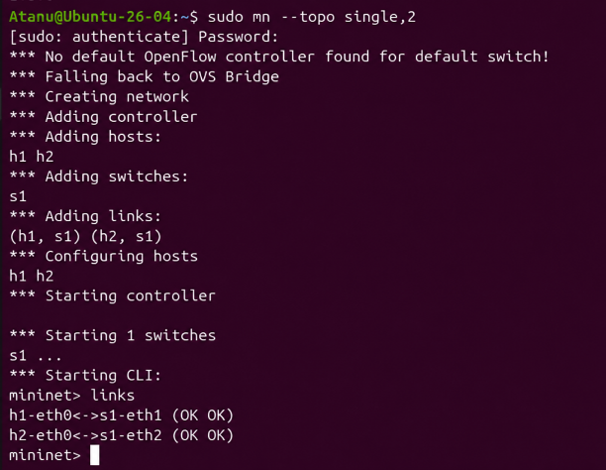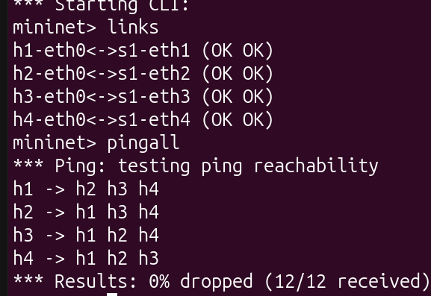
Star config Star link and pingall

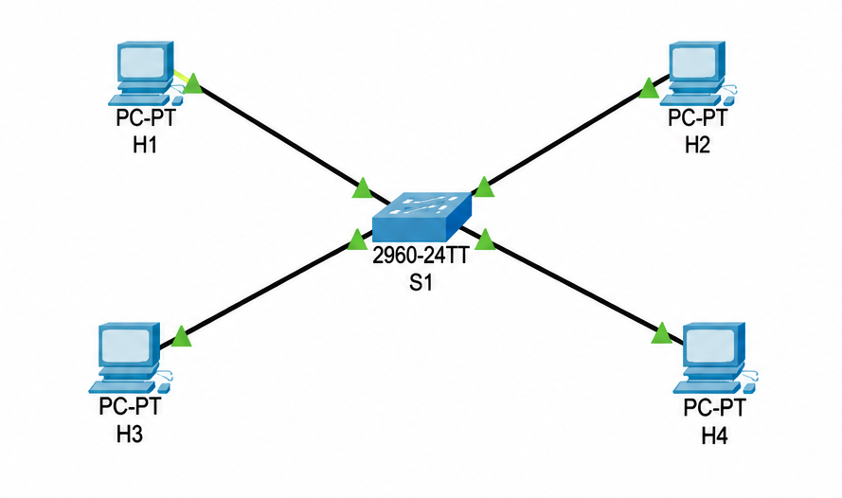
Diagram: Star with 4 host

2.Linear Topology
- Linear with 3 hosts
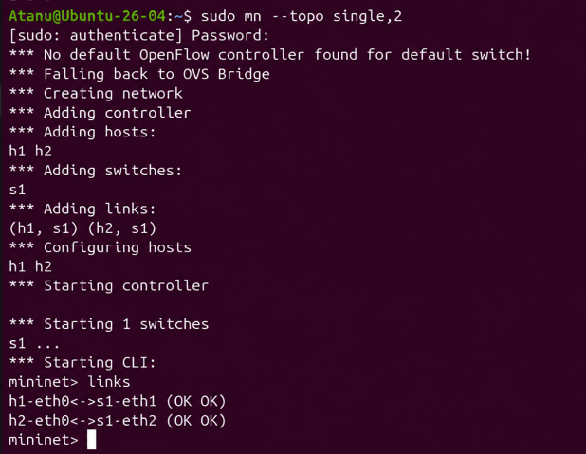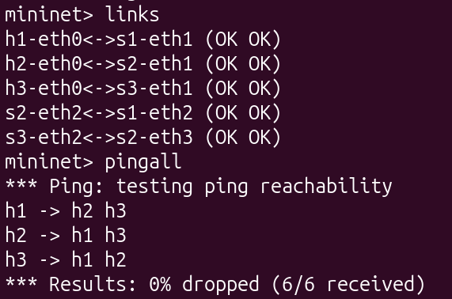
Linear Config Links and pingall

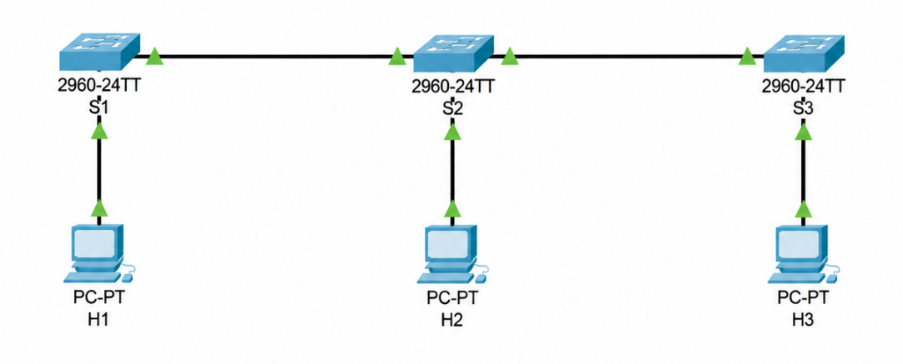

Diagram: Linear with 3 hosts

- Linear with 5 hosts
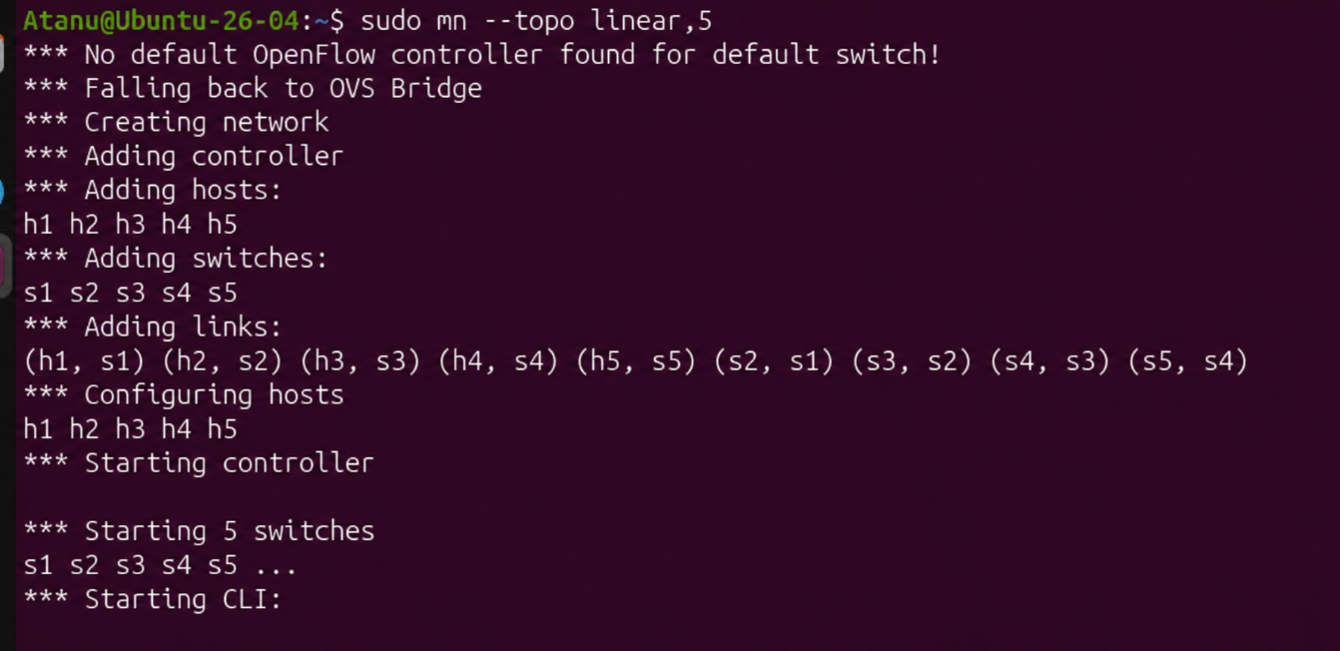
Linear Config
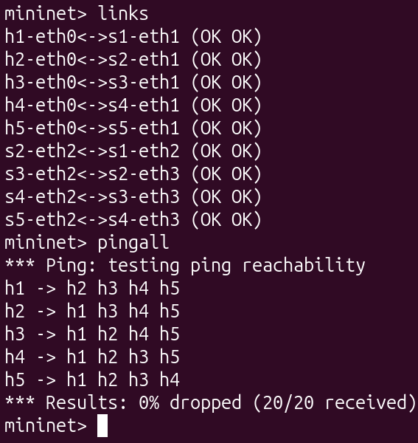
Links and pingall command

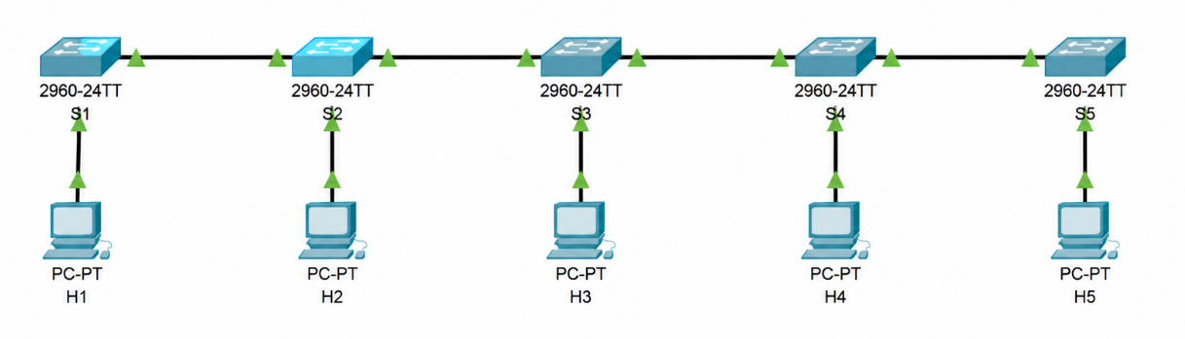
Diagram: Linear with 5 hosts
3.Tree Topology
- Tree with 4 hosts

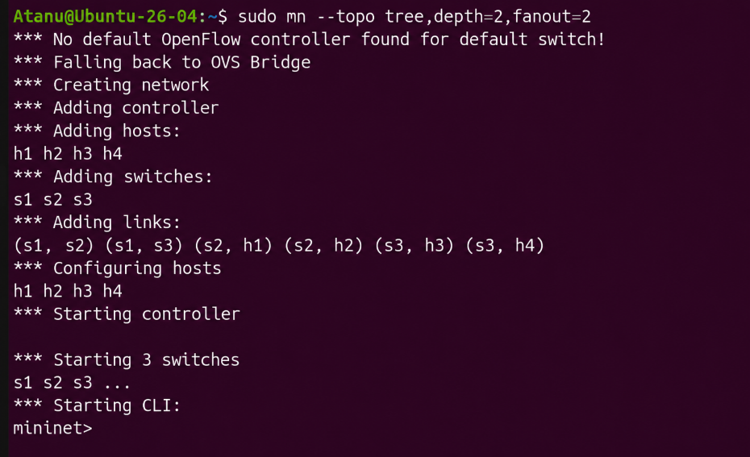
Tree Config
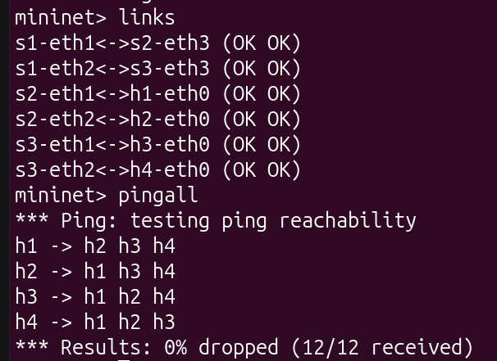
Links and pingall command

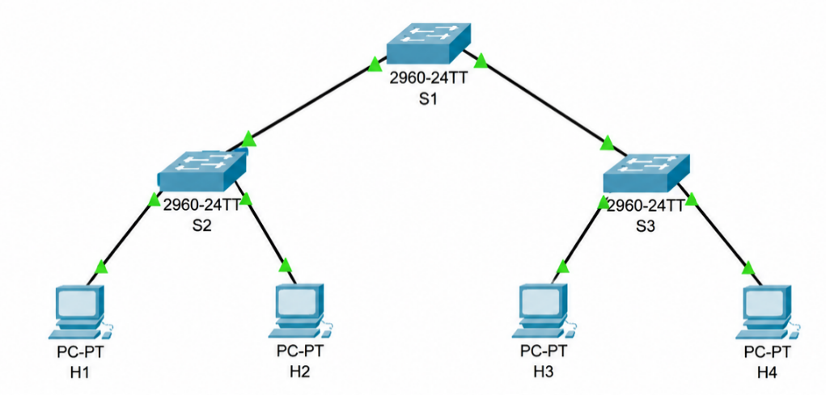
Diagram: Tree with 4 hosts
- Tree with 8 hosts
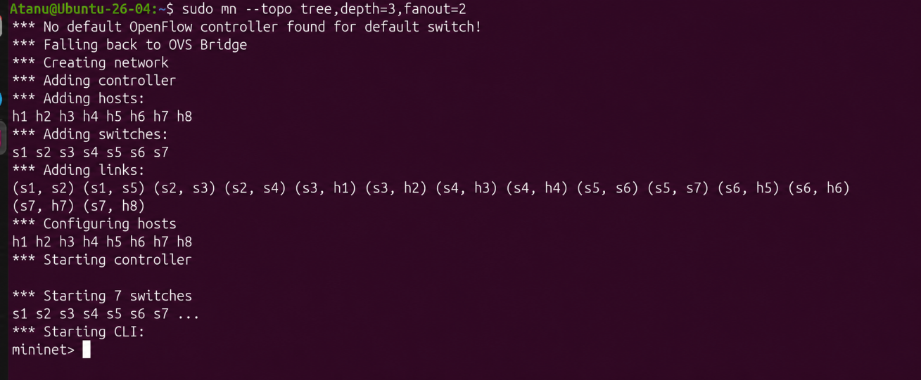
Tree Config
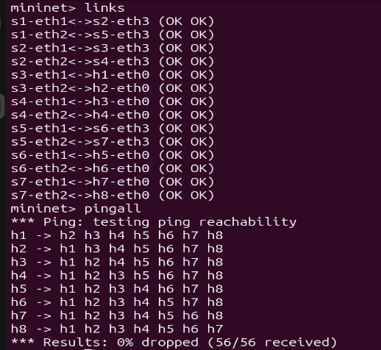
Links and pingall command

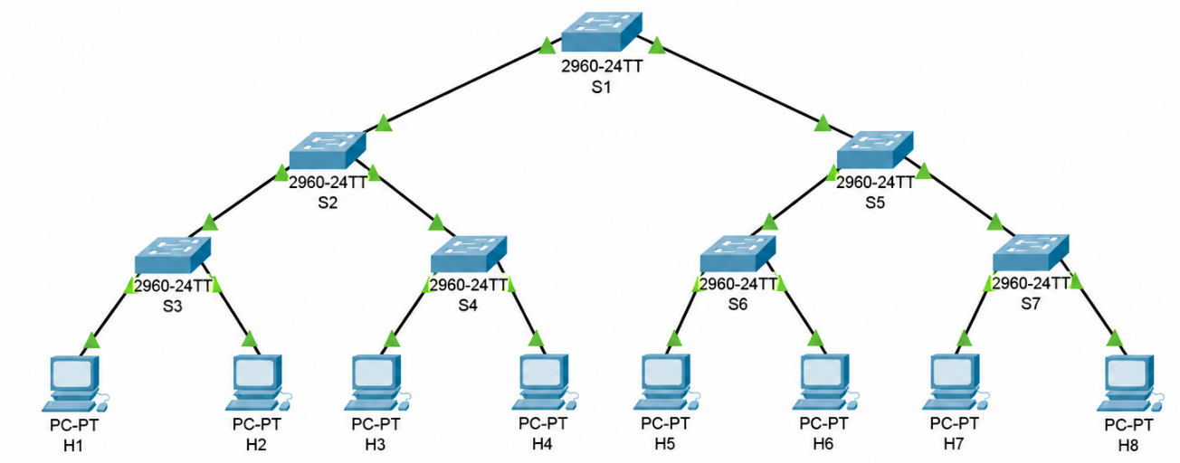

Diagram: Tree with 8 hosts

4.Ring Topology
a. Ring topology — 4 nodes
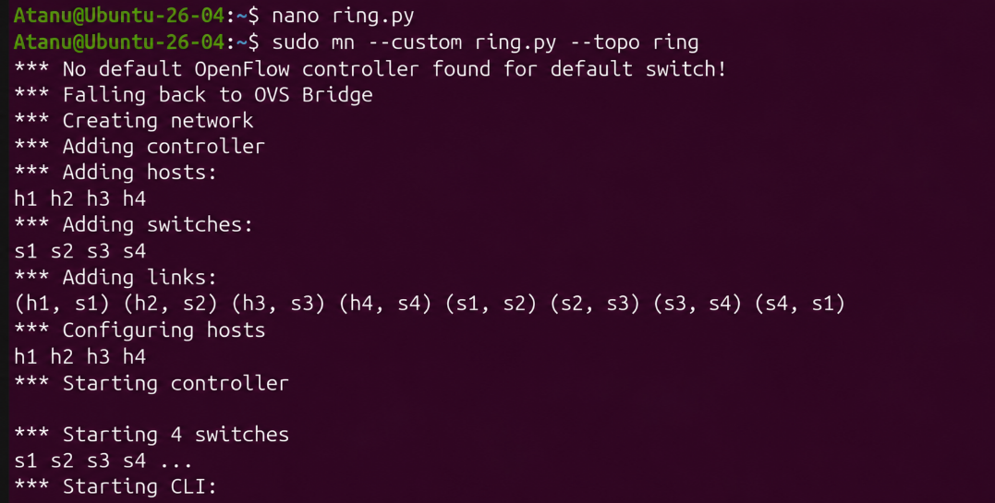
Ring Config
Python Code
from mininet.topo import Topo
from mininet.net import Mininet
from mininet.node import OVSSwitch
from mininet.cli import CLI

class RingTopo(Topo):
def build(self):
s1 = self.addSwitch('s1')
s2 = self.addSwitch('s2')
s3 = self.addSwitch('s3')
s4 = self.addSwitch('s4')

h1 = self.addHost('h1')
h2 = self.addHost('h2')
h3 = self.addHost('h3')
h4 = self.addHost('h4')

self.addLink(h1, s1)
self.addLink(h2, s2)
self.addLink(h3, s3)
self.addLink(h4, s4)

self.addLink(s1, s2)
self.addLink(s2, s3)
self.addLink(s3, s4)
self.addLink(s4, s1)

topo = RingTopo()
net = Mininet(topo=topo, switch=OVSSwitch, controller=None)

net.start()

# Enable STP on all switches
for s in net.switches:
s.cmd('ovs-vsctl set Bridge', s.name, 'stp_enable=true')

print('\nRing topology started successfully.')
print('STP enabled on all switches.')
print('Type links and pingall at the Mininet prompt.\n')

CLI(net)

net.stop()

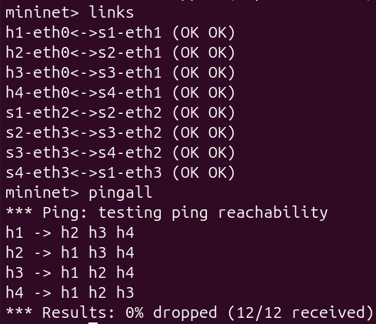
Links and pingall command

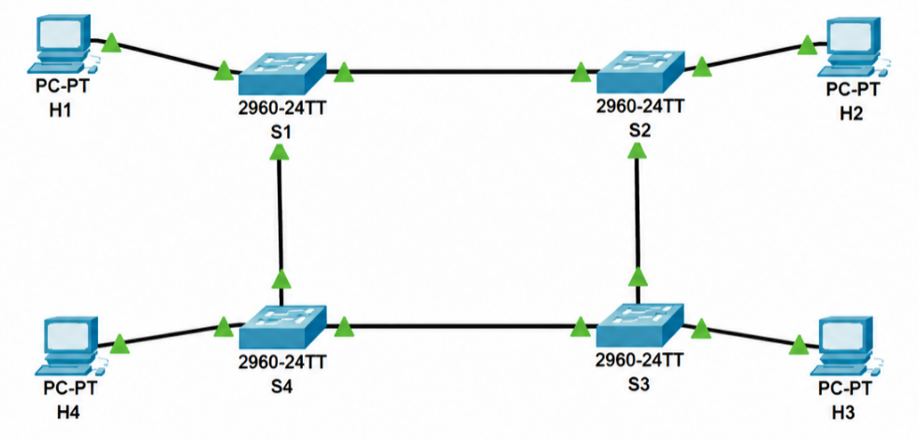
Diagram: Ring topology — 4 nodes

b. Ring with 6 nodes
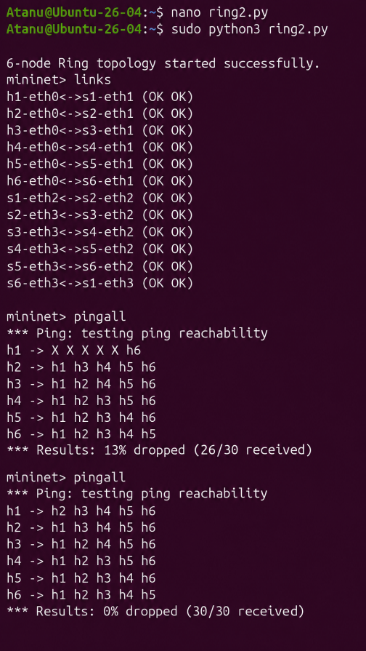
Ring config , links and pingall command

Python Code
from mininet.topo import Topo
from mininet.net import Mininet
from mininet.node import OVSSwitch
from mininet.cli import CLI

class RingTopo(Topo):
def build(self):
switches = [self.addSwitch(f's{i}') for i in range(1, 7)]
hosts = [self.addHost(f'h{i}') for i in range(1, 7)]

for i in range(6):
self.addLink(hosts[i], switches[i])

for i in range(6):
self.addLink(switches[i], switches[(i + 1) % 6])

topo = RingTopo()
net = Mininet(topo=topo, switch=OVSSwitch, controller=None)

net.start()

for s in net.switches:
s.cmd('ovs-vsctl set Bridge', s.name, 'stp_enable=true')
s.cmd('ovs-vsctl set-fail-mode', s.name, 'standalone')

print("\n6-node Ring topology started successfully.")

CLI(net)

net.stop()

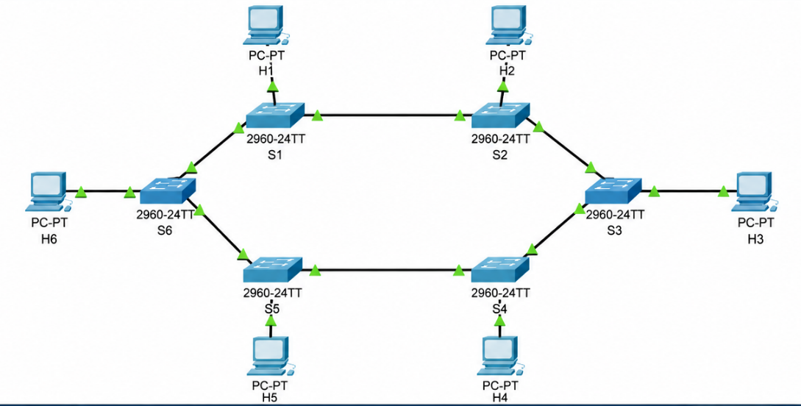
Diagram : Ring with 6 host

5.Mesh Topology
- Mesh with 4 nodes
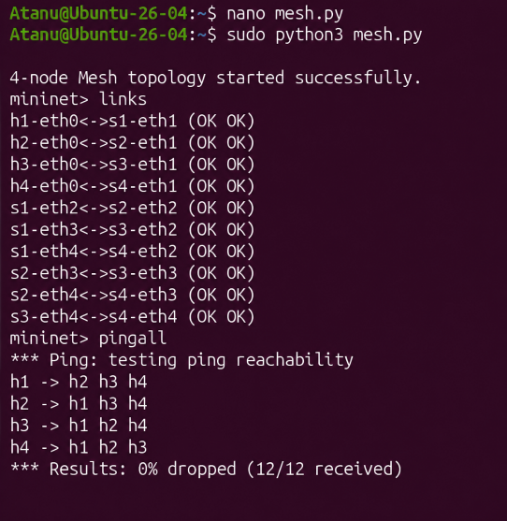
Mesh Config, links and pingall
Python Code
from mininet.topo import Topo
from mininet.net import Mininet
from mininet.node import OVSSwitch
from mininet.cli import CLI

class MeshTopo(Topo):
def build(self):
s1 = self.addSwitch('s1')
s2 = self.addSwitch('s2')
s3 = self.addSwitch('s3')
s4 = self.addSwitch('s4')

h1 = self.addHost('h1')
h2 = self.addHost('h2')
h3 = self.addHost('h3')
h4 = self.addHost('h4')

self.addLink(h1, s1)
self.addLink(h2, s2)
self.addLink(h3, s3)
self.addLink(h4, s4)

self.addLink(s1, s2)
self.addLink(s1, s3)
self.addLink(s1, s4)
self.addLink(s2, s3)
self.addLink(s2, s4)
self.addLink(s3, s4)

topo = MeshTopo()
net = Mininet(topo=topo, switch=OVSSwitch, controller=None)

net.start()

for s in net.switches:
s.cmd('ovs-vsctl set Bridge', s.name, 'stp_enable=true')
s.cmd('ovs-vsctl set-fail-mode', s.name, 'standalone')

print("\n4-node Mesh topology started successfully.")

CLI(net)

net.stop()

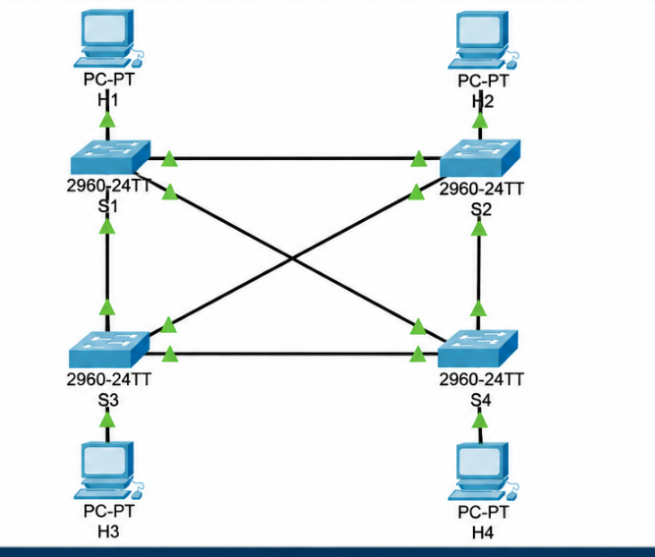
Diagram: Mesh with 4 nodes

- Mesh with 6 nodes
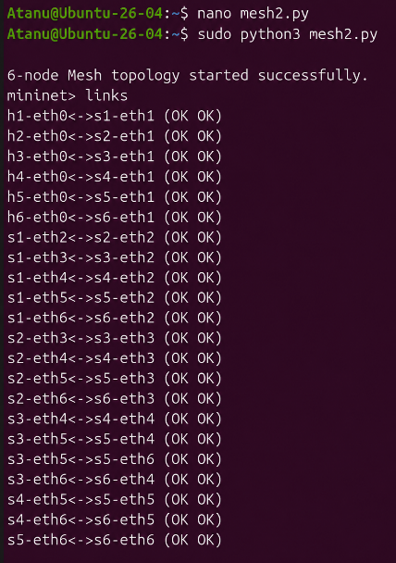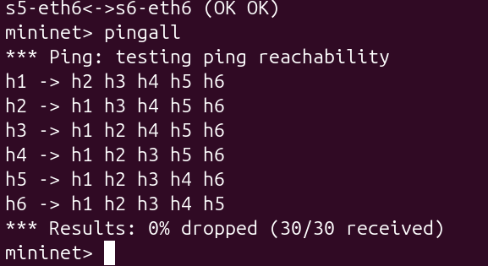
Mesh config and links pingall command

Python Code
from mininet.topo import Topo
from mininet.net import Mininet
from mininet.node import OVSSwitch
from mininet.cli import CLI

class MeshTopo(Topo):
def build(self):
switches = [self.addSwitch(f's{i}') for i in range(1, 7)]
hosts = [self.addHost(f'h{i}') for i in range(1, 7)]

# Connect each host to a switch
for i in range(6):
self.addLink(hosts[i], switches[i])

# Fully connect the 6 switches
for i in range(6):
for j in range(i + 1, 6):
self.addLink(switches[i], switches[j])

topo = MeshTopo()

net = Mininet(
topo=topo,
switch=OVSSwitch,
controller=None
)

net.start()

for s in net.switches:
s.cmd('ovs-vsctl set Bridge', s.name, 'stp_enable=true')
s.cmd('ovs-vsctl set-fail-mode', s.name, 'standalone')

print("\n6-node Mesh topology started successfully.")

CLI(net)

net.stop()

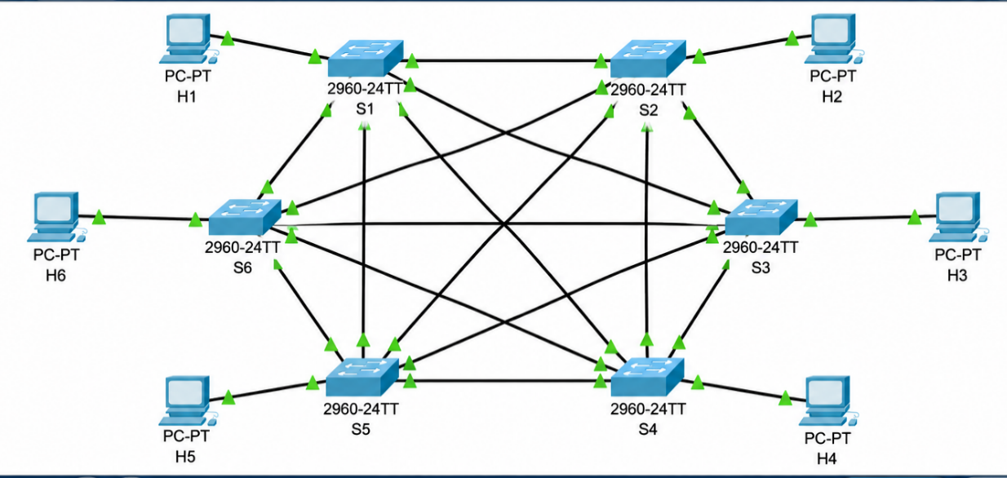
Diagram: Mesh with 6 hosts

